**Contrast Limited Adaptive Histogram Equalization for detection of masses and micro calcification of mammogram images**

**INTRODUCTION:**

Histogram modeling techniques (*e.g.* histogram equalization) provide a sophisticated method for modifying the dynamic range and contrast of an image by altering that image such that its [intensity histogram](http://homepages.inf.ed.ac.uk/rbf/HIPR2/histgram.htm) has a desired shape. Unlike [contrast stretching](http://homepages.inf.ed.ac.uk/rbf/HIPR2/stretch.htm), histogram modeling operators may employ *non-linear* and *non-monotonic* transfer functions to map between [pixel intensity values](http://homepages.inf.ed.ac.uk/rbf/HIPR2/value.htm) in the input and output images. Histogram equalization employs a monotonic, non-linear mapping which re-assigns the intensity values of pixels in the input image such that the output image contains a uniform distribution of intensities (*i.e.* a flat histogram). This technique is used in image comparison processes (because it is effective in detail enhancement) and in the correction of non-linear effects introduced by, say, a digitizer or display system.

The histogram processing methods discussed above are global in the sense that they apply a transformation function whose form is based on the intensity level distribution of an entire image. Although this method can enhance the overall contrast and dynamic range of an image (thereby making certain details more visible), there are cases in which enhancement of details over small areas (*i.e.* areas whose total pixel contribution to the total number of image pixels has a negligible influence on the global transform) is desired. The solution in these cases is to derive a transformation based upon the intensity distribution in the local neighborhood of every pixel in the image.

The histogram processes described above can be adapted for local enhancement. The procedure involves defining a neighborhood around each pixel and, using the histogram characteristics of this neighborhood, to derive a transfer function which maps that pixel into an output intensity level.

Contrast Limited AHE (CLAHE) differs from ordinary adaptive histogram equalization in its contrast limiting. This feature can also be applied to global histogram equalization, giving rise to contrast limited histogram equalization (CLHE), which is rarely used in practice. In the case of CLAHE, the contrast limiting procedure has to be applied for each neighbourhood from which a transformation function is derived. CLAHE was developed[[3]](https://en.wikipedia.org/wiki/Adaptive_histogram_equalization#cite_note-clahe87-3) to prevent the overamplification of noise that adaptive histogram equalization can give rise to.

This is achieved by limiting the contrast enhancement of AHE. The contrast amplification in the vicinity of a given pixel value is given by the slope of the transformation function. This is proportional to the slope of the neighbourhood [cumulative distribution function](https://en.wikipedia.org/wiki/Cumulative_distribution_function) (CDF) and therefore to the value of the histogram at that pixel value. CLAHE limits the amplification by clipping the histogram at a predefined value before computing the CDF. This limits the slope of the CDF and therefore of the transformation function. The value at which the histogram is clipped, the so-called clip limit, depends on the normalization of the histogram and thereby on the size of the neighbourhood region. Common values limit the resulting amplification to between 3 and 4.

It is advantageous not to discard the part of the histogram that exceeds the clip limit but to redistribute it equally among all histogram bins.

**LITERATURE SURVEY:**

|  |  |  |  |  |
| --- | --- | --- | --- | --- |
| Year | Author | Title | Keyword | Remarks |
| 2013 | Mohan S., Ravishankar M. | Modified Contrast Limited Adaptive Histogram Equalization Based on Local Contrast Enhancement for Mammogram Images (Base Paper) | CLAHE, PSNR, Local Contrast Modification (LCM) | Optimal Contrast improvement for recognition of masses and small scale calcification of mammogram pictures utilizing Contrast Limited Adaptive Histogram Equalization (CLAHE) in light of local contrast modification (LCM) is exhibited in this paper. The LCM-CLAHE is proposed to feature the finer hidden points of interest in mammogram pictures and to change the level of contrast improvement. |
| 2012 | Fari Muhammad Abubakar | Image Enhancement using Histogram Equalization and Spatial Filtering | Image Enhancement, Histogram Equalization, MATLAB | The focus of this paper is an endeavor to enhance the nature of digital images utilizing Histogram Equalization and Spatial Filters in MATLAB and the outcomes acquired are examined featuring the execution of every technique. It was seen from the aftereffects of histogram equalization, a high difference was accomplished for the picture making the intensity values spread over a full range. However blurring was observed while using bigger filter masks. |
| 2011 | M.Sundaram, K.Ramar, N. Arumugami, G.Prabini | HISTOGRAM BASED CONTRAST ENHANCEMENT FOR MAMMOGRAM IMAGES | Histogram Equalization, Histogram Modification, Local Contrast Enhancement, Mammogram Images | Contrast enhancement for the detection of micro calcification of mammograms based on the Histogram Modified Contrast Limited Adaptive Histogram Equalization (HM-CLAHE) is presented. Histogram equalization is an effective and simple technique for contrast enhancement. The Histogram Modified Contrast Limited Adaptive Histogram Equalization (HMCLAHE) is proposed in this paper to adjust the level of contrast enhancement, which in turn gives the resultant image a strong contrast and brings the local details for more relevant interpretationIt incorporates both histogram modifications as an optimization technique and Contrast Limited Adaptive Histogram Equalization. |
| 2008 | Papadopoulos, D.I., Fotiadis, L., Costarido | Improvement of microcalcification cluster detection in mammography utilizing image enhancement techniques | Mammography image enhancement | Image enhancement algorithms were utilized for the improvement of contrast features and the suppression of noise in several types of medical images and more specifically in mammograms.In this work, the effect of an image enhancement processing stage on parameter tuning of a CAD system for the detection of microcalcifications in mammograms is assessed. Specifically, five (5) image enhancement algorithms were tested: (a)CLAHE (b) LRM (c) RDW and its variants. The first two are derived from conventional image analysis methodologies based on histogram equalization and linear stretching approaches, respectively |
| 2014 | Kuldeep Singh, Rajiv Kapoor | Image enhancement using Exposure based Sub Image Histogram Equalization | Histogram equalization  Image information content  Image exposure | This paper presents a novel Exposure based Sub-Image Histogram Equalization (ESIHE) method for contrast enhancement for low exposure gray scale image. The histogram clipping is combined with HE to provide control on over enhancement. This method proved to be very effective for enhancing under exposed images. The entropy measures of the ESIHE method outperform other HE based methods. |
| 1998 | Etta D. Pisano, Shuquan Zong, Bradley M. Hemminger, Marla Deluca, R. Eugene Johnston, Keith Muller, M. Patricia Braeuning, and Stephen M. Pizer | Contrast Limited Adaptive Histogram Equalization Image Processing to Improve the Detection of Simulated Spiculations in Dense Mammograms | Mammography,image processing, contrast limited adaptive histogram equalization, observer studies, breast cancer, spiculations. | The purpose of this paper was to determine whether Contrast Limited Adaptive Histogram Equalization (CLAHE) improves detection of simulated spiculations in dense mammograms. Lines simulating the appearance of spiculations, a common marker of malignancy when visualized with masses, were embedded in dense mammograms digitized at 50 micron pixels, 12 bits deep. There was a statistically significant improvement in detection performance for spiculations with CLAHE over unenhanced images when the region size was set at 32 with a clip level of 2, and when the region size was set at 32 with a clip level of 4 |
| 2011 | Sundaram,M., Ramar,K., Arumugam,N., Prabin | Histogram Modified Local Contrast Enhancement for mammogram images | Histogram Equalization  Histogram Modification  Local contrast enhancement  Mammogram images | Contrast enhancement of mammograms based on Histogram Equalization (HE) is presented. The standard histogram equalization (HE) usually results in excessive contrast enhancement because of lack of control on the level of enhancement. The Histogram Modified Local Contrast Enhancement (HM-LCE) is introduced in this paper to adjust the level of contrast enhancement, which in turn gives the resultant image a strong contrast and also brings the local details present in the original image for more relevant interpretation.The proposed method is more suitable for all types of mammogram images of fatty, fatty-glandular and dense-glandular mammogram images and its performance is evaluated for all 22 numbers of Mias mammogram images with microcalcification. |
| 2015 | Wei-Yen Hsu, Ching-Yao Chou | Medical Image Enhancement Using Modified Color Histogram Equalization | Color Image, Image Enhancement, Medical Image Processing, Peak signal-to-noise ratio, Histogram Equalization | Although it is widely studied and applied, traditional histogram equalization achieves poor image enhancement results because it does not consider hue preservation. This study proposes a novel image enhancement method that incorporates hue preservation to address this problem. The results show that, compared with the equalized image of each RGB color channel using the traditional method, the proposed method yields superior results, with higher accuracy in terms of mean squared error and peak signal-to-noise ratio |
| 2017 | Nabin Kharel , Abeer Alsadoon , P.W.C. Prasad , A. Elchouemi | Early Diagnosis of Breast Cancer Using Contrast Limited Adaptive Histogram Equalization (CLAHE) and Morphology Methods | Pre-processing,CLAHE,Morphology,Brest Cancer | The main aim of this paper is to enhance using hybrid solution for early diagnosis of breast cancer using mammogram images. For the CAD system any image processing system follows mainly four steps that is image pre-processing, segmentation, features extraction and classification and evaluation. For this research purpose we follow the same structure using best possible methods in each stage found in literature review and proposed solution. From the experiment hybrid image enhancement method using CLAHE and Morphology method helps to enhance image for further computation in CAD system to early diagnosis of breast cancer using mammogram images while maintaining processing time as previous best solution. |
| 2013 | [ShibinWu](https://www.ncbi.nlm.nih.gov/pubmed/?term=Wu%20S%5BAuthor%5D&cauthor=true&cauthor_uid=24416072), [Shaode Yu](https://www.ncbi.nlm.nih.gov/pubmed/?term=Yu%20S%5BAuthor%5D&cauthor=true&cauthor_uid=24416072), [Yuhan Yang](https://www.ncbi.nlm.nih.gov/pubmed/?term=Yang%20Y%5BAuthor%5D&cauthor=true&cauthor_uid=24416072), [Yaoqin Xie](https://www.ncbi.nlm.nih.gov/pubmed/?term=Xie%20Y%5BAuthor%5D&cauthor=true&cauthor_uid=24416072) | Feature and Contrast Enhancement of Mammographic Image based on multiscale analysis and morphology | CLAHE, Histogram Equalization, contrast improvement index, mathematical morphology | A new algorithm for feature and contrast enhancement of mammographic images is proposed in this paper. The approach bases on multiscale transform and mathematical morphology. First of all, the Laplacian Gaussian pyramid operator is applied to transform the mammography into different scale subband images. In addition, the detail or high frequency subimages are equalized by contrast limited adaptive histogram equalization (CLAHE) and low-pass subimages are processed by mathematical morphology. Finally, the enhanced image of feature and contrast is reconstructed from the Laplacian Gaussian pyramid coefficients modified at one or more levels by contrast limited adaptive histogram equalization and mathematical morphology, respectively. For performance evaluation of the proposed algorithm, SNR, contrast evaluation criterion and contrast improvement index are adopted |

**METHODOLOGY:**

In the present medical scenario detection of breast cancer in its early stage is a very immense challenge. Even with the advancement in medical technology it is complex to detect cancerous cells in its premature stage. In order to deal with the low quality or low contrast X-Ray images, Image Enhancement is used.

In medical imaging (such as mammogram enhancement) local contrast are more important than global contrast. In such type of applications Global Histogram Equalization (GHE) is insufficient because it cannot deal with local features of original image due to its global nature. Pizer had proposed AHE in which the input image is divided into blocks and then the mapping functions are computed for those blocks using CLAHE. The standard CLAHE method produces over enhancement which results in the loss of some local information. In order to overcome this limitation we have proposed LCM-CLAHE. This method will produce optimal contrast without losing any local information of the mammogram image which is most important for detection of breast cancer. The proposed method LCM-CLAHE consists of two stages of processing to increase the potentiality of contrast enhancement and to preserve the local details in the images.

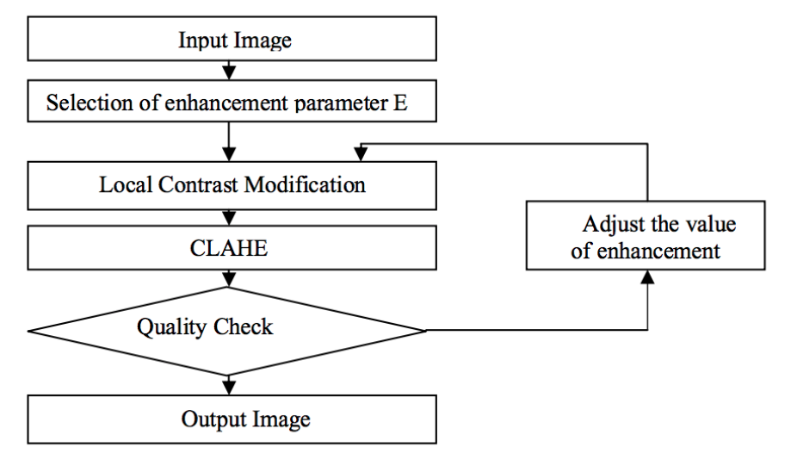

*Fig. 1. Flowchart of proposed LCM-CLAHE*

Figure 1 show the steps involved in the proposed method. The original image and the enhancement parameter is given as input to LCM. In LCM we modify the image to produce the finer details hidden in the mammogram image and that output image is give as input to CLAHE and CLAHE will further enhance the image with quality check. The quality check used in the proposed method is PSNR.

**LIMITATIONS OF CLAHE:**

CLAHE does have disadvantages. Since the method is aimed at optimizing contrast, there is no 1 to 1 relationship between the gray values of the original image and the CLAHE processed result; consequently, CLAHE images are not suited for quantitative measurements that rely on a physical meaning of image intensity. A more serious problem are artifacts (like block artifacts) that sometimes occur when high-intensity gradients are present.

**REFERENCES:**

[1] Zuiderveld, Karel. “Contrast Limited Adaptive Histograph Equalization.” Graphic Gems IV. San Diego: Academic Press Professional, 1994. 474–485.

[2] Sundaram, M., Ramar, K., Arumugam, N., Prabin, G.: Histogram based contrast

enhancement for mammogram images

[3] Papadopoulos, D.I., Fotiadis, L., Costarido: Improvement of microcalcification cluster

detection in mammography utilizing image enhancement techniques.

[4] Mohan S., Ravishankar M. (2013) Modified Contrast Limited Adaptive Histogram Equalization Based on Local Contrast Enhancement for Mammogram Images. In: Das V.V., Chaba Y. (eds) Mobile Communication and Power Engineering. Communications in Computer and Information Science, vol 296. Springer, Berlin, Heidelberg